Peg Perego Tatamia Highchair - Stripes Gray
Retails for $399 ONLY $239 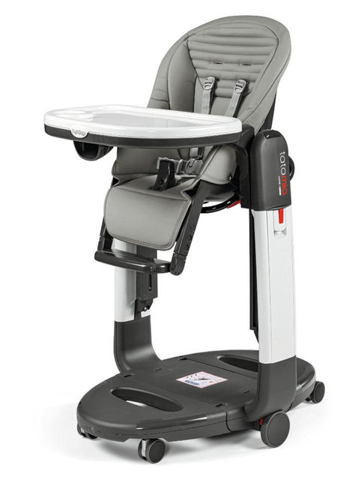
Call or text Eli
(845)642-0309
Million Dollar Baby Classic Foothill 4-in-1 Convertible Crib Retails for $399 ONLY $209

